**SOUTHERN REGIONAL PLANNING PANEL**

|  |  |
| --- | --- |
| RPP No | PPSSTH-44 |
| DA Number | DA-2020/528 |
| Local Government Area | Southern Regional Panel - Wollongong |
| Proposed Development | Demolition of existing structures, construction of 19 storey hotel including 3 levels of basement parking, 120 room / suites, 6 commercial suites, lobby, cafe and associated hotel facilities. |
| Street Address | 357-359 Crown Street, Wollongong |
| Applicant/Owner | Design Workshop Australia |
| Lodgement date | 2 June 2020 |
| Recommendation | Conditional approval |
| Number of Submissions  Number of Unique Objections | Five (5)  Two (2) objections, Three (3) support. |
| Regional Development Criteria (Schedule 7 of the SEPP (State and Regional Development) 2011 | Proposed development has a Capital Investment Value exceeding $30 million. |
| List of All Relevant s S4.15(1)(a) Matters | s4.15 (1)(a)(i) Any [environmental planning instrument](http://www.austlii.edu.au/au/legis/nsw/consol_act/epaaa1979389/s4.html#environmental_planning_instrument)s:  State Environmental Planning Policies (SEPPs):   * State Environmental Planning Policy (State and Regional Development) 2011 * State Environmental Planning Policy No. 55 – Remediation of Land * State Environmental Planning Policy (Infrastructure) 2007   Local Environmental Planning Policies   * Wollongong Local Environmental Plan 2009   *Other policies:*   * Wollongong City-Wide Development Contributions Plan 2019 * Wollongong Community Participation Plan 2019   s4.15(1)(a)(ii) Any proposed instrument that is or has been the subject of public consultation under the Act and that has been notified to the consent authority:   * N/A   s4.15 (1)(a)(iii) Any [development control plan](http://www.austlii.edu.au/au/legis/nsw/consol_act/epaaa1979389/s4.html#development_control_plan):   * Wollongong Development Control Plan 2009   s4.15 (1)(a)(iiia) any planning agreement that has been entered into under section 7.4, or any draft planning agreement that a developer has offered to enter into under section 7.4   * N/A   s4.15 (1)(a)(iv) the [regulations](http://www.austlii.edu.au/au/legis/nsw/consol_act/epaaa1979389/s4.html#regulation): e.g Regs 92, 93, 94, 7.12, 288   * N/A |
| List all documents submitted with this report for the panel’s consideration | **Attachments**  Attachment 1 Aerial photograph  Attachment 2 WLEP zoning map  Attachment 3 Plans  Attachment 4 Clause 4.6 – Building height  Attachment 5 – Clause 4.6 – Building separation  Attachment 6 – DCP compliance tables  Attachment 7 – Draft conditions of consent  **Other documents** |
| Clause 4.6 request | Yes Clause 4.3 height of buildings. Clause 8.6, building separation. |
| Summary of key submissions | * height exceedance * car parking non-compliance * building separation non-compliance * notification * view impacts |
| Report prepared by | Nigel Lamb – Senior Development Project Officer |
| Report Date | 7 December 2020 |

Summary of s4.15 matters

|  |  |
| --- | --- |
| Have all recommendations in relation to relevant s4.15 matters been summarised in the Executive Summary of the assessment report? | **Yes** |
| Legislative clauses requiring consent authority satisfaction |  |
| Have relevant clauses in all applicable environmental planning instruments where the consent authority must be satisfied about a particular matter been listed, and relevant recommendations summarized, in the Executive Summary of the assessment report?  e.g. Clause 7 of SEPP 55 - Remediation of Land, Clause 4.6(4) of the relevant LEP | **Yes** |
| Clause 4.6 Exceptions to development standards |  |
| If a written request for a contravention to a development standard (clause 4.6 of the LEP) has been received, has it been attached to the assessment report? | **Yes** |
| Special Infrastructure Contributions |  |
| Does the DA require Special Infrastructure Contributions conditions (S7.24)? | **N/A** |
| Conditions |  |
| Have draft conditions been provided to the applicant for comment? | **Yes** |
|  |  |

**Assessment report and Recommendation Cover Sheet**

Executive Summary

**Reason for consideration by** **Regional Planning Panel**

The proposal has been referred to Joint Regional Planning Panel as it involves general development with a capital investment value of more than $30 million. The CIV estimate for the project is $35,000,000

**Proposal**

The proposal is for demolition of all structures on site and construction of a 19-storey building comprised of 6 commercial office suites and an 120 room hotel located above three levels of basement car parking.

**Permissibility**

The site is zoned B3 Commercial Core pursuant to Wollongong Local Environmental Plan 2009. The proposal is categorised as a commercial premises and tourist and visitor accommodation, both of which are permissible with consent.

**Consultation**

The proposal was notified in accordance with Council’s Notification Policy and received five submissions, three in support and two objections. The concerns raised are discussed at section 1.5 below.

Satisfactory referrals were received from Council Safer Community Action Team (SCAT), Geotechnical, Stormwater, Landscape, Traffic and Environment Officers.

Satisfactory referrals were also received from Transport for NSW (TfNSW) and Endeavour Energy.

**Main Issues**

* 3.5m height exceedance
* Non-compliant building separation at upper levels
* Non-compliance with numeric car parking rate
* Commercial floor to ceiling heights and depth

**RECOMMENDATION**

It is recommended that DA-2020/528 be approved subject to the conditions outlined in attachment 7.

1. Application overview
   1. PLANNING CONTROLS

The following planning controls apply to the development

State Environmental Planning Policies

* State Environmental Planning Policy (State and Regional Development) 2011
* State Environmental Planning Policy No. 55 – Remediation of Land
* State Environmental Planning Policy (Infrastructure) 2007

Local Environmental Plans

* Wollongong Local Environmental Plan (WLEP) 2009

Development Control Plans

* Wollongong Development Control Plan (WDCP) 2009

Other Policies/Regulations

* Wollongong Community Participation Plan 2019
* Wollongong City Wide Development Contributions Plan 2019
  1. DETAILED DESCRIPTION OF PROPOSAL

The proposal is for construction of a 19-storey hotel with three levels of basement car parking and includes the following:

* 120 rooms/suites for hotel guests
* 6 commercial spaces over 4 levels
* Lobby and concierge area with void above
* Ground level café (open to general public)
* Café/restaurant with outdoor dining area on level 3 (hotel guests / commercial occupants only)
* Hotel facilities including rooftop communal space, pool, gym, day spa, multi-purpose rooms
* 24 commercial and 65 hotel car parking spaces with valet parking service and loading bay
* Upgrades to public domain
  1. Background

Pre-lodgement meeting PL-2020/33 was held for the proposal.

The Design Review Panel (DRP) reviewed the proposal on 30 June and then the Panel chair subsequently reviewed amended plans on 22 November, the notes of which are contained at attachment 5.

Key changes that have been made to the plans originally submitted include:

* Removal of vehicular access to Crown Street
* Reduction in height exceedance from ~6m to 3.5m
* Improvements to the ground floor elevation on Gladstone Avenue
* Reconfiguration of valet area and waste servicing at basement 1 level
* Adjustments to the northern portion of the tower to include horizontal shading
* Greater clarity of materials to be used, particularly with regard to thermal performance and reflectivity of glazed areas
* Introduction of window hoods and additional windows to the stair well on western elevation in order to provide greater visual interest
* Minor increase to height of terrace balustrades to comply with wind assessment
* Preparation of detailed sections

SRPP briefing

On 14 October 2020 the SRPP was briefed on the proposal via video link. The key issues discussed were:

* Building height: The proposal sought to exceed the maximum permitted height of 60m under WLEP 2009 (65.9m proposed). A clause 4.6 variation request has been submitted however Council advised that the request was not well founded.
* Building separation: The proposal seeks to vary the building separation requirements of clause 8.6 of WLEP 2009 (above 45m the proposal is required to be set back 14m and to the northern boundary the minimum setback is 8.4m).
* Car parking: The proposal seeks a variation to the numeric car parking rates. It was noted that the proposal is in a central location adjacent to the train station and major bus routes. This and the character of the use are considered to be a good basis for the proposed reduction in parking. Other measures have been incorporated to support the reduction (e.g. green travel plan, car pool spaces, greater than required end of trip facilities).
* Design excellence: Reflectivity, heat gain from large expanses of glazing, wind impacts, environmental sustainability. Additional information was been requested in relation to these items.

Customer service actions

There are no outstanding customer service requests of relevance to the development.

* 1. Site description

The site is located at 357-359 Crown Street, Wollongong and the title reference is Lot 2 DP 201949.

The site is on the corner of Gladstone Avenue and Crown Street on the fringe of the Wollongong city centre. There is a fall of approximately 4m from northwest to southeast.

There are currently two vehicle accessways, one from the southeast corner onto Gladstone Avenue, the other from the northwest corner onto Crown Street.

The site contains open hardstand car parking.

There is a right of way benefitting Lot 1 DP 201949 running along the southern boundary of the site.

Adjoining development is as follows:

* To the immediate south of the site are two smaller lots each containing single storey dwelling houses setback substantially from the street. Both are occupied by commercial uses. To the south of these is a Mantra serviced apartment development.
* Opposite the site to the east on the other side of Gladstone Avenue is a three-storey commercial building containing multiple smaller tenancies and a car park.
* To the west of the site is a two-storey commercial building.
* To the north on the opposite side of Crown Street is a row of two storey attached commercial buildings.
* Wollongong Train station is located approximately 200m to the southeast
* The hospital is located approximately 300m to the west.

The locality is generally characterised by a mixture of commercial development of varying density.

Property constraints

Council records identify the land as being impacted by the following constraints:

* Contamination: Council records indicate the site as being potentially contaminated due to previous land uses.

There is an easement for access across the southern boundary of the site as illustrated below.

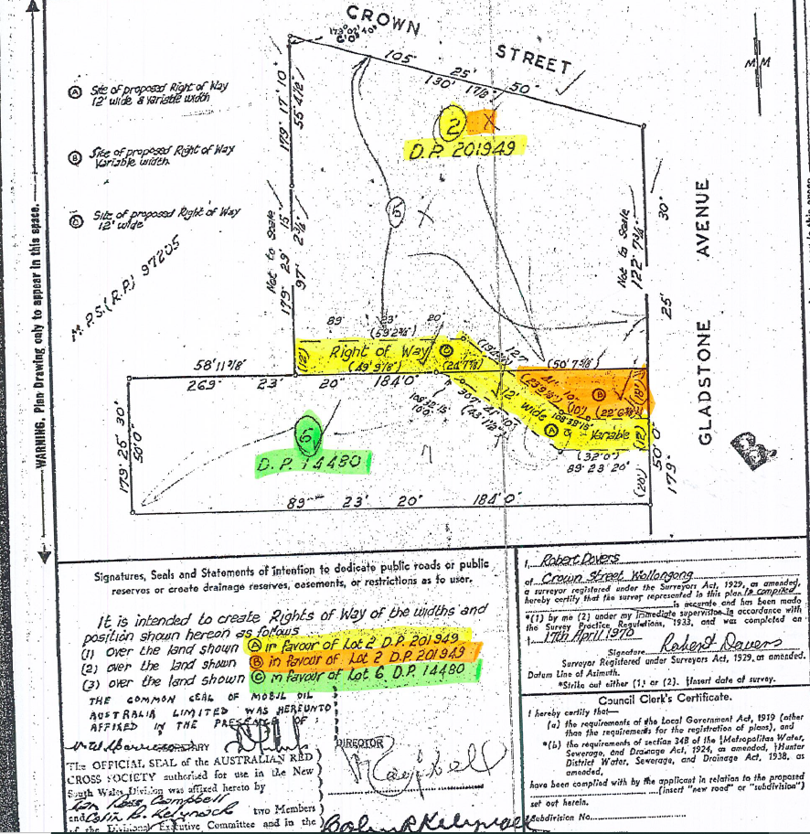

Figure 1: Right of way

* 1. Submissions

The application was notified in accordance with Council’s Community Participation Plan 2019 from 5-19 June 21020. Five submissions were received, including 2 objections and 3 letters of support. Concerns raised are discussed below.

|  |
| --- |
|  |

Figure 2: Notification map

Table 1: Submissions

| Concern | Comment |
| --- | --- |
| The proposal does not comply with the over-generous height limits; | The proposal was amended to reduce the height exceedance from 6m to 3.5m. Discussion regarding the proposed height variation is contained at clause 4.6. |
| It does not comply with the over-generous floor space limits because it uses net rather gross floor space in the calculations; | The FSR complies with the maximum permitted for the land. GFA plans have been submitted that are consistent with the definition for GFA in WLEP 2009. |
| It does not comply with car parking standards by an undisclosed amount and the Green Travel Plan makes no attempt to quantify the effectiveness of its proposals in relation to requirements; | The proposal seeks a variation to the minimum recommended car parking for the commercial component. The variation is supported in this instance in consideration of the following:   * Close proximity to Wollongong Train Station and numerous bus routes * Inclusion of car pool spaces * Provision of end of trip facilities above the minimum requirements   It is noted that the green travel plan itself does not contain a significant amount of measurable commitments. However, the fixed inclusions above are considered to provide meaningful steps to reducing reliance on private vehicles. |
| It does not comply with building separation controls | A variation to the building separation requirement of clause 8.6 of WLEP 2009 is requested for levels 14-18. A satisfactory clause 4.6 variation has been submitted in this regard as discussed in the body of this report. |
| It would constitute an undesirable precedent for others to follow. | The variations to the building separation, car parking and height are considered to have merit in this instance and suitable justification has been provided. Design excellence is considered to have been demonstrated and the proposal is not considered to set an undesirable precedent. |
| Concerns regarding insufficient notification given the Advertiser has not been available for some time and Council office closure for three months and stay at home directive during COVID. This presents an obstacle to those who are not computer literate/have inadequate computer access. | The application was notified in accordance with Councils community participation plan. |
| The proposal should comply with the maximum height limit. | The proposal has been reduced in height such that only the plant on the rooftop exceeds the height limit. The merit of this is discussed at clause 4.6 of WLEP in the body of this report. |
| Variation request based on court judgement that is not comparable to current situation. | As noted above, the extent of the height variation has been reduced such that it is only the rooftop plant that breaches the height. |
| History of current height limits | This is not a matter for consideration under the DA. |
| Heights above 60m will have view corridor impacts. | The building is located within an identified key view shed from Flagstaff Hill towards Mt Kembla and the escarpment. The 60m height plane does not significantly obstruct views of Mt Kembla or protrude above the escarpment as viewed from Flagstaff Hill. The proponent has provided a view impact analysis from that vantage point that illustrates this impact, as contained at Figure 4 of this report. A 3d model provided by the applicant has been input into Councils city centre model which verifies this. |
| Views along Crown St will end up dominated by high rise. | WLEP 2009 sets the height limits for the commercial core. Views along Crown Street are not subject to controls or protections under the LEP or WDCP2009. |
| Concern regarding construction within right of way. | The only physical construction within the right of way is for a driveway which is consistent with the terms of the easement. |
| Concern about driveway width extending beyond the easement. | The driveway is contained within the easement. |
| Concern about traffic conflicts between the entry/exit for the development and the exit driveway immediately adjacent. | Vehicles entering the site are only approaching from the south and sight lines are not obstructed. There are no obvious alternate locations for a driveway entry to the site given access to Crown Street is not supported by either Council or TfNSW. |

* 1. Consultation
     1. Internal consultation

Satisfactory referrals have been received from Council’s Safer Community Action Team (SCAT), Geotechnical, Stormwater, Landscape, Traffic and Environment Officers.

* + 1. External consultation

Transport of NSW (TfNSW)

TfNSW were referred the application as the site has frontage to a classified road. The proposal was amended at the request of TfNSW and Council to remove access to crown Street and provide it solely off Gladstone Avenue. TfNSW have provided recommended conditions.

Endeavour Energy

Endeavour Energy have provided recommended guidelines for work in respect of potential impact on Endeavour Energy network connections infrastructure pursuant to clause 45 of SEPP Infrastructure.

Design Review Panel

The application was reviewed by the Design Review Panel as required by clause 7.18 of Wollongong Local Environmental Plan, being development that is over 35m in height. The Panel reviewed the proposal on 30 June 2020 following lodgement. Amended plans were further reviewed by the Panel Chair on the 22 November, the notes of which are contained at attachment 5.

Outstanding matters identified by the Panel Chair that have now been addressed include the following:

* Relocation of fire booster from northern elevation adjacent to café to eastern elevation adjacent to discharge pipe chamber to better activate Crown Street.
* The planter on the southern edge of the terrace has been increased to 3m in width and the planter and screen to the east fronting Gladstone Avenue has been removed to allow the terrace to overlook the street. The pergola above the terrace has been amended to include adjustable louvers that allow the space to be fully enclosed.
* Hotel lift exits have been amended to exit to the east adjacent to the lobby, rather than into the corridor adjacent to the commercial lifts.

Matters raised by the Panel Chair that have not been changed and the justification are as follows:

* Bike rack adjacent to café: The bike rack is in a highly visible location where it is most likely to be utilised and provided with passive surveillance. There are not considered to be obvious alternate locations that would be more suitable.
* Large void above valet area: This area has been retained. The proponent claims this provides an impressive entry area and visual connection to the lobby. Enclosing that area as suggested by the Panel Chair would likely result in additional gross floor area which would also mean reconsideration of GFA and likely losing GFA elsewhere in order to remain compliant with the LEP. The lack of direct connection between that space and the footpath level along Gladstone Avenue is not optimal. However, it is in part a function of the level changes on the site. The void area is entirely within the building and is not considered to compromise other areas or the built form. Retention of this aspect is not considered a determinative issue.
* Sunken terrace area adjacent to the hotel entry: The site has a significant grade along the Crown Street frontage which presents challenges to how level entry points are provided into the building. The sunken area allows for a more generous level area adjacent to the entry. It is considered that balustrades and retaining walls within the setback are less than optimal however the proposed arrangement is not considered unreasonable or to significantly detract from the design.
* A physical samples board has not been provided however a schedule of materials and finishes is included and plans appropriately notated.

1. Environmental Planning and Assessment Act 1979
   1. Section 4.15(1)(A)(1) any environmental planning instrument
      1. State Environmental Planning Policy (State and Regional Development) 2011

The Southern Regional Planning Panel is the determining authority for the development pursuant to Part 4 of the SEPP as the development has a capital investment value of more than $30 million.

* + 1. State Environmental Planning Policy No. 55 – Remediation of Land

Council records indicate the site is contaminated as a result of previous land uses. The proposal was accompanied by a Detailed Site Investigation (DSI) which identified underground storage tanks and fill and a Remediation Action Plan (RAP) was duly undertaken in accordance with the recommendations in the DSI. Subject to the recommendations in the RAP being implemented, the site can be made suitable for the proposed development. Council’s Environment Officer has reviewed the proposal in this regard and conditions of consent have been recommended. The site can be made suitable for the intended use of the land under clause 7.

* + 1. State Environmental Planning Policy (Infrastructure) 2007

101 Development with frontage to classified road

The site is located on Crown Street which is a classified road. TfNSW were forwarded the proposal for comment. Concern was raised with regard to a proposed vehicular driveway egress onto Crown Street as this is a classified road where additional driveways are generally prohibited. The subject driveway egress has since been removed and the TfNSW have now provided recommended conditions of consent.

102 Impact of road noise or vibration on non-road development

The application was accompanied by an acoustic report (Acoustic Assessment dated 19 May 2020 prepared by Harwood Acoustics). That report assessed the potential impact of noise emission from the ongoing operation of the Hotel at existing residential receptors, and the potential for noise intrusion into the Hotel rooms from passing road traffic on Crown Street and Gladstone Avenue.

The report recommended appropriate glazing to hotel rooms as a means of mitigating traffic noise and this requirement is reflected in the recommended conditions of consent.

* + 1. Wollongong Local Environmental Plan 2009

Clause 1.4 Definitions

*commercial premises* means any of the following—

(a) business premises,

(b) office premises,

(c) retail premises.

*tourist and visitor accommodation* means a building or place that provides temporary or short-term accommodation on a commercial basis, and includes any of the following—

(a) backpackers’ accommodation,

(b) bed and breakfast accommodation,

(c) farm stay accommodation,

*(d) hotel or motel accommodation,*

(e) serviced apartments,

but does not include—

(f) camping grounds, or

(g) caravan parks, or

(h) eco-tourist facilities.

*hotel or motel accommodation* means a building or place (whether or not licensed premises under the Liquor Act 2007) that provides temporary or short-term accommodation on a commercial basis and that—

(a) comprises rooms or self-contained suites, and

(b) may provide meals to guests or the general public and facilities for the parking of guests’ vehicles,

but does not include backpackers’ accommodation, a boarding house, bed and breakfast accommodation or farm stay accommodation.

Note.

Hotel or motel accommodation is a type of tourist and visitor accommodation—see the definition of that term in this Dictionary.

Part 2 Permitted or prohibited development

Clause 2.2 – zoning of land to which Plan applies

The zoning map identifies the land as being zoned B3 Commercial Core.

Clause 2.3 – Zone objectives and land use table

The objectives of the zone are as follows:

* To provide a wide range of retail, business, office, entertainment, community and other suitable land uses that serve the needs of the local and wider community.
* To encourage appropriate employment opportunities in accessible locations.
* To maximise public transport patronage and encourage walking and cycling.
* To strengthen the role of the Wollongong city centre as the regional business, retail and cultural centre of the Illawarra region.
* To provide for high density residential development within a mixed-use development if it—
  1. (a) is in a location that is accessible to public transport, employment, retail, commercial and service facilities, and
  2. (b) contributes to the vitality of the Wollongong city centre.

The proposal has regard to the above objectives.

The land use table permits the following uses in the zone.

Advertising structures; Amusement centres; Boarding houses; Car parks; Centre-based child care facilities; **Commercial premises;** Community facilities; Educational establishments; Entertainment facilities; Exhibition homes; Function centres; Helipads; Hostels; **Hotel or motel accommodation**; Information and education facilities; Medical centres; Oyster aquaculture; Passenger transport facilities; Places of public worship; Recreation areas; Recreation facilities (indoor); Recreation facilities (outdoor); Registered clubs; Respite day care centres; Restricted premises; Roads; Self-storage units; Seniors housing; Service stations; Sex services premises; Shop top housing; Tank-based aquaculture; **Tourist and visitor accommodation**; Veterinary hospitals; Wholesale supplies

The proposal is categorised as a *commercial premises* and *tourist and visitor accommodation* as defined above and is permissible in the zone with development consent.

Part 4 Principal development standards

Clause 4.3 Height of buildings

The proposed maximum building height reaches 63.5m and exceeds the maximum of 60m permitted for the site. The variation is discussed at clause 4.6 below.

Clause 4.4A Floor space ratio – Wollongong city centre

(3) For land within Zone B3 Commercial Core with a site area equal to or greater than 800 square metres and less than 2,000 square metres and a street frontage equal to or greater than 20 metres, the maximum floor space ratio for any building on that site is—

 f the building is used only for purposes other than residential purposes

X is 

Site area: 1,631

X = (1,631 – 800) / 1,200 = 0.6925‬

Maximum FSR: 3.5 + 2.5 x 0.6925 = 5.231

GFA: 8,525.4m²

Proposed FSR: 8,524.4/1,631 = 5.23:1

Clause 4.6 variations to development standards

The proposal seeks a variation to the maximum height under clause 4.3 and also to the building separation requirements under clause 8.6. The variation statements submitted by the proponent are contained at attachment 4 and 5respectively. These are discussed in turn below.

4.3 Height of buildings

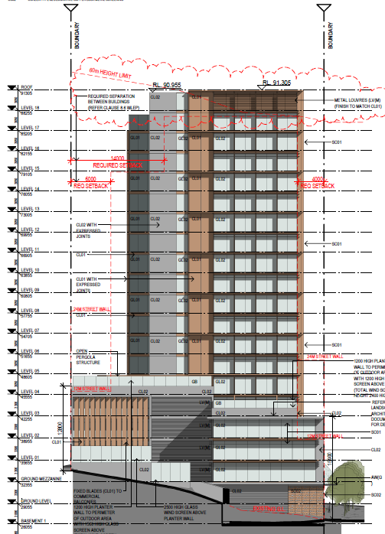

Figure 3: Southern elevation - Height variation

|  |  |
| --- | --- |
| WLEP 2009 clause 4.6 proposed development departure assessment | |
| Development departure | *Clause 4.3 height of buildings.*  *Clause 4.3 requires that the height of a building on any land is not to exceed the maximum height shown for the land on the Height of Buildings Map.* |
| Is the planning control in question a development standard | Yes |
| 4.6 (3) Written request submitted by applicant contains a justification: | |
| that compliance with the development standard is unreasonable or unnecessary in the circumstances of the case, and | A satisfactory clause 4.6 variation has been submitted. |
| that there are sufficient environmental planning grounds to justify contravening the development standard. | Yes |
| 4.6 (4) (a) Consent authority is satisfied that: | |
| the applicant’s written request has adequately addressed the matters required to be demonstrated by subclause (3), and | The applicant’s Clause 4.6 Statement forms attachments 4.  The applicant’s written request seeks to justify that compliance with the development standard is unreasonable or unnecessary in the circumstances of the case based  There are considered to be a number of shortcomings in the clause 4.6 justification submitted by the applicant. Assertions made in the statement and Council response are as follows:   * Restricting the built form envelope as anticipated by the planning controls is “completely impractical for a City Centre B3 zoned site at this location, and therefore, unreasonable”. Response: This is not substantiated. The heights at this location are generous and other than the grade of the site there are no particular site constraints (such as flood levels) impacting the development. * The proposed form results in a slimline tower aimed at achieving design excellence for the corner centrepiece position, and to reduce the height would partially result in a wider tower footprint. Response: A reduction of 3.5m to comply with the maximum would be imperceptible at street level and would not necessarily necessitate a wider tower. There are large void areas within the building envelope that could potentially accommodate additional GFA without changing the profile of the building.   Notwithstanding the above, the following observations are made in respect of the provisions of subclause (3).  In terms of the application of the LEP height control, Council consistently enforces compliance and is not considered to have abandoned it. Variations have however been granted for minor departures considering unique circumstances and a number of examples are provided in the applicant submission. Whilst these are all quite unique, a common theme in the examples provided is sloping sites where there is no resultant additional GFA or other impacts.  The subject site slopes in a general west to east direction with a fall of approximately 4m. The tower is under the maximum height at the high side of the site and over at the low side. The portion of the tower that exceeds the height plane is rooftop plant and does not contribute to any gross floor area. In respect of likely impacts, the height exceedance is not considered to contribute to any notable additional adverse overshadowing or view impacts.  The context of the site includes land with a maximum height of 120m to the east and land to the west rising in grade along Crown Street. Consideration of these factors does lend support to the argument of compliance being unreasonable or unnecessary |
| the proposed development will be in the public interest because it is consistent with the objectives of the particular standard and the objectives for development within the zone in which the development is proposed to be carried out, and | Clause 4.3 building height objective:  (*a) to establish the maximum height limit in which buildings can be designed and floor space can be achieved,*  *(b) to permit building heights that encourage high quality urban form,*  *(c) to ensure buildings and public areas continue to have views of the sky and receive* exposure to sunlight.  The variation is not considered to be inconsistent with these objectives. The building complies with the maximum floor space ratio. The urban form is considered to exhibit design excellence. The non-compliant portion is not considered to contribute to any significant additional overshadowing or to adversely interrupt views to the sky  The objectives for development within the B3 Commercial Core zone are:   * *To provide a wide range of retail, business, office, entertainment, community and other suitable land uses that serve the needs of the local and wider community.* * *To encourage appropriate employment opportunities in accessible locations.* * *To maximise public transport patronage and encourage walking and cycling.* * *To strengthen the role of the Wollongong city centre as the regional business, retail and cultural centre of the Illawarra region.* * *To provide for high density residential development within a mixed-use development if it—*   *(a) is in a location that is accessible to public transport, employment, retail, commercial and service facilities, and*  *(b) contributes to the vitality of the Wollongong city centre.*  The proposed building provides commercial uses on ground level which is consistent with the above objectives.  Given the proposal is consistent with the zone objectives and the objectives of Clause 4.3 despite the development departure, the development is considered to be in the public interest in this instance.  Notwithstanding disagreement with some of the reasoning for the proposed variation provided in the proponent’s clause 4.6 statement, there is considered to be merit in the variation request in this instance and the proposal is supported. |
| the concurrence of the Secretary has been obtained. | Concurrence is not required as the SRPP is the determining authority. |

8.6 Building separation within Zone B3 Commercial Core or Zone B4 Mixed Use

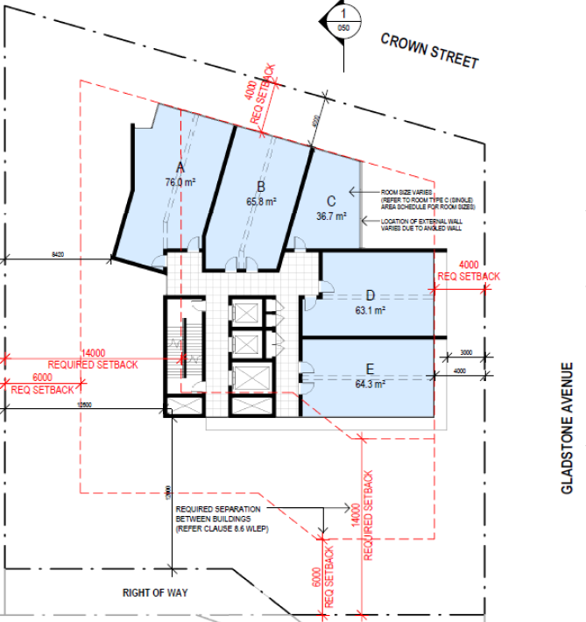

|  |  |
| --- | --- |
| WLEP 2009 clause 4.6 proposed development departure assessment | |
| Development departure | Clause 8.6 Building separation.  *Clause 8.6(3) requires that if a building contains a dwelling, all habitable parts of the dwelling including any balcony must not be less than—*  *(a) 20 metres from any habitable part of a dwelling contained in any other building, and*  *(b) 16 metres from any other part of any other building*. |
| Is the planning control in question a development standard | Yes |
| 4.6 (3) Written request submitted by applicant contains a justification: | |
| that compliance with the development standard is unreasonable or unnecessary in the circumstances of the case, and | A satisfactory clause 4.6 variation has been submitted. |
| that there are sufficient environmental planning grounds to justify contravening the development standard. | Yes |
| 4.6 (4) (a) Consent authority is satisfied that: | |
| the applicant’s written request has adequately addressed the matters required to be demonstrated by subclause (3), and | The applicant’s written request seeks to justify that compliance with the development standard is unreasonable or unnecessary in the circumstances of the case based on the following rationale:   * The proposal adequately addresses the objectives of the standard * The standard has been abandoned * There are unique site circumstances to warrant the provision of reduced setback * The proposed building form does not result in any significant adverse impacts and achieves a good urban outcome. * The proposal achieves design excellence. * The proposal does not result in any adverse environmental outcomes.   The applicant’s Clause 4.6 Statement forms attachment 5. The written request has adequately addressed the matters required to be addressed under subclause (3). |
| the proposed development will be in the public interest because it is consistent with the objectives of the particular standard and the objectives for development within the zone in which the development is proposed to be carried out, and | Clause 8.6 Building separation objective:  *(1) The objective of this clause is to ensure sufficient separation of buildings for reasons of visual appearance, privacy and solar access.*  The variation is not considered to be inconsistent with these objectives. The non-compliance is at levels 14-17 only where a separation distance of 28m from any other building is required which means a minimum building setback of 14m from the southern and western boundaries. The southern setback complies but the western setback is between 8.4 and 11.8m. The tower is of reasonably slender proportions. The western elevation does not include primary windows and the non-compliant portion is not considered to result in significant additional overshadowing.  The objectives for development within the B3 Commercial Core zone are:   * *To provide a wide range of retail, business, office, entertainment, community and other suitable land uses that serve the needs of the local and wider community.* * *To encourage appropriate employment opportunities in accessible locations.* * *To maximise public transport patronage and encourage walking and cycling.* * *To strengthen the role of the Wollongong city centre as the regional business, retail and cultural centre of the Illawarra region.* * *To provide for high density residential development within a mixed-use development if it—*   *(a) is in a location that is accessible to public transport, employment, retail, commercial and service facilities, and*  *(b) contributes to the vitality of the Wollongong city centre.*  The proposed building provides commercial uses on ground level which is consistent with the above objectives.  Given the proposal is consistent with the zone objectives and the objectives of Clause 8.6 despite the development departure, the development is considered to be in the public interest in this instance. |
| the concurrence of the Secretary has been obtained. | Concurrence is not required as the SRPP is the determining authority. |

Part 7 Local provisions – general

Clause 7.1 Public utility infrastructure

The proposal was referred to Endeavour Energy who have advised of their requirements and recommendations with respect to the energy network.

Clause 7.13 Certain land within business zones

The proposal does not have a residential component at ground level and includes at least one entrance and door/window on the frontage.

Clause 7.18 Design excellence in Wollongong city centre and at key sites

1. (4) In considering whether development to which this clause applies exhibits design excellence, the consent authority must have regard to the following matters:
   1. (a) whether a high standard of architectural design, materials and detailing appropriate to the building type and location will be achieved,
   2. The building has been designed with guidance from an urban designer. The materials and finishes and tower form are considered to have architectural merit. The proposal has been reviewed by the Design Review Panel and their concerns have been addressed in revised plans.
   3. (b) whether the form and external appearance of the proposed development will improve the quality and amenity of the public domain,
   4. The proposal will upgrade the footpath for the entire frontage. The building will occupy a site that has laid vacant for many years. The building is considered to have a high-quality façade and the building form is considered to positively contribute to the skyline and public domain.
   5. (c) whether the proposed development detrimentally impacts on view corridors,
   6. The proposal is located within the view shed towards the escarpment from Flagstaff Hill as identified within Chapter D13 section 3.10. Views towards the proposed building take in recently approved large developments in the city centre located between the site and the foreshore. 3D modelling indicates that the tower will not protrude above the line of the escarpment or significantly obscure a view to Mt Kembla as indicated at Figure 4 below.
   7. 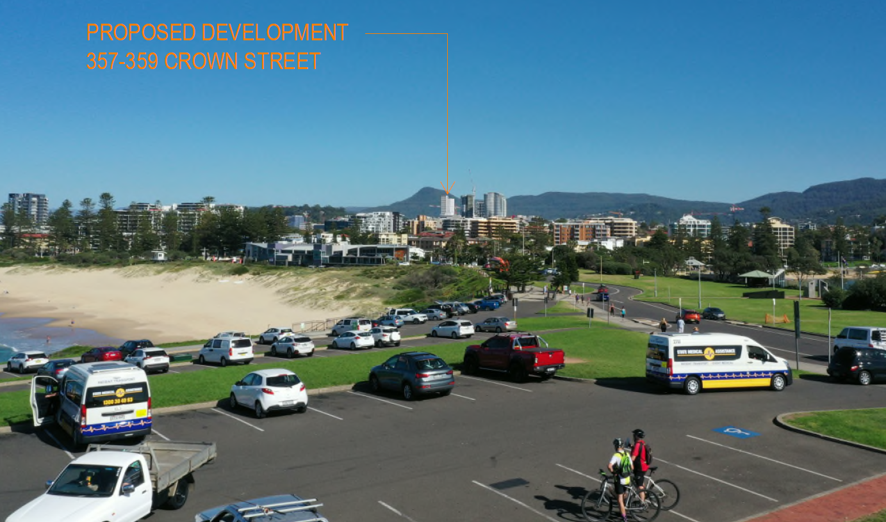

Figure 4: View from Flagstaff Hill

* 1. (d) whether the proposed development detrimentally overshadows an area shown distinctively coloured and numbered on the Sun Plane Protection Map,
  2. N/A
  3. (e) how the proposed development addresses the following matters:
     1. (i) the suitability of the land for development,
     2. The site is in close proximity to the CBD, Wollongong train station and hospital precinct. The land is not constrained in any significant way. The land is considered suitable for the proposal.
     3. (ii) existing and proposed uses and use mix,
     4. The proposal is considered suitable in respect of existing and likely future uses.
     5. (iii) heritage issues and streetscape constraints,
     6. The site is not heritage listed nor is it located in or adjacent to any heritage precincts. There is a large heritage listed Morton Bay Fig on the site next door however the proposal is not expected to adversely impact on that tree.
     7. (iv) the location of any tower proposed, having regard to the need to achieve an acceptable relationship with other towers (existing or proposed) on the same site or on neighbouring sites in terms of separation, setbacks, amenity and urban form,
     8. The proposal does not satisfy the building separation controls of Chapter D13 to the western boundary. This is discussed in greater detail at Chapter A1 below.
     9. (v) bulk, massing and modulation of buildings,
     10. The bulk, massing and modulation of the building is considered acceptable.
     11. (vi) street frontage heights,
     12. The street frontage heights comply with the DCP and are considered to provide a suitable response to the locality.
     13. (vii) environmental impacts such as sustainable design, overshadowing, wind and reflectivity,
     14. A Section J Report and ESD report has been submitted outlining sustainability measures to be implemented.
     15. A wind impact assessment has been provided which outlines measures to ensure wind thresholds are not exceeded.
     16. A Solar reflectivity analysis was prepared for the proposed development outlining suitable glazing to mitigate glare.
     17. The recommendations of these reports are reflected in the conditions of consent.
     18. Overshadowing impacts are not considered unreasonable given the locality and built form controls.
     19. (viii) the achievement of the principles of ecologically sustainable development,
     20. The proposal was supported by an ESD report that outlines measures to address sustainability. Conditions of consent are recommended regarding meeting these commitments.
     21. (ix) pedestrian, cycle, vehicular and service access, circulation and requirements,
     22. The proposal provides clear and accessible pedestrian access points with level access into and within the development. Bicycle parking is provided in secure locations. Suitable servicing arrangements are integrated into the development. Internal circulation for cars and service vehicles complies.
     23. (x) impact on, and any proposed improvements to, the public domain.
     24. The proposal will upgrade the footpath for the site frontage and the built form is considered to positively contribute to the public domain.

Part 8 Local provisions—Wollongong city centre

Clause 8.1 Objectives for development in Wollongong city centre

The objectives of this Part and (in so far as it relates to the Wollongong city centre) clause 7.18 are as follows—

1. *(a) to promote the economic revitalisation of the Wollongong city centre,*
2. *(b) to strengthen the regional position of the Wollongong city centre as a multifunctional and innovative centre that encourages employment and economic growth,*
3. *(c) to protect and enhance the vitality, identity and diversity of the Wollongong city centre,*
4. *(d) to promote employment, residential, recreational and tourism opportunities within the Wollongong city centre,*
5. *(e) to facilitate the development of building design excellence appropriate to a regional city,*
6. *(f) to promote housing choice and housing affordability,*
7. *(g) to encourage responsible management, development and conservation of natural and man-made resources and to ensure that the Wollongong city centre achieves sustainable social, economic and environmental outcomes,*
8. *(h) to protect and enhance the environmentally sensitive areas and natural and cultural heritage of the Wollongong city centre for the benefit of present and future generations.*
9. The proposal is satisfactory with regard to these objectives.

Clause 8.4 Minimum building street frontage

A minimum frontage of 20m is required under this control. The proposal complies.

Clause 8.6 Building separation within Zone B3 Commercial Core or Zone B4 Mixed Use

A variation is requested to the building separation requirement above 45m in height.

Clause 8.6(1)(c) requires a 28m building separation above 45m in height.

As there is no existing building adjacent the site at this height, a boundary setback of 14m is therefore required. For levels 14-19 the boundary setback comes to between 8.5m and 11.8m.

A variation statement has been submitted in this regard as contained at attachment 5, and the request is discussed in further detail at clause 4.6 of the LEP above.

* 1. Section 4.15(1)(a)(ii) any proposed instrument

N/A

* 1. Section 4.15(1)(a)(iii) any development control plan
     1. Wollongong Development Control Plan 2009

The proposal is considered to be acceptable with regard to the DCP. An assessment against the DCP provisions are contained at attachment 6, variations are discussed below.

CHAPTER A1 – INTRODUCTION

8 Variations to development controls in the DCP

Commercial floor depth

(a) The control being varied;

Chapter D13, 2.4 Building depth and bulk: A maximum building depth of 25m is recommended as well as a recommendation that all points of office floor be no greater than 10m from a source of natural daylight.

(b) The extent of the proposed variation and the unique circumstances as to why the variation is requested;

The commercial space up to podium height does not comply, being approximately 30m. The commercial floor area has a small central area that is also greater than 10m from a source of natural light, as shown at Figure 5 below. There are no particularly unique circumstances for non-compliance. The commercial space is open plan with extensive glazing to the north, south and also some to the east. The layout is considered to provide generous natural lighting and with the exception of the small central area.

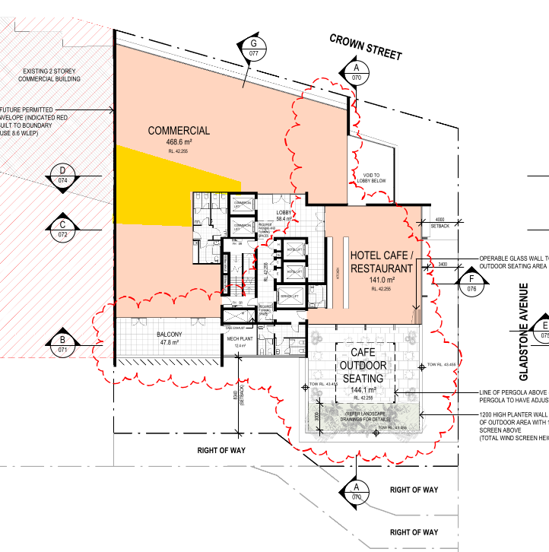

Figure 5: Area greater than 10m from source of natural light

(c) Demonstrate how the objectives are met with the proposed variations; and

The proposal is considered satisfactory with regard to the objectives of the control as follows:

1. *a) To promote the design and development of sustainable buildings.*

The variation is not considered to result in the sustainability of the building being significantly compromised.

1. *b) To achieve the development of living and working environments with good internal amenity and minimise the need for artificial heating, cooling and lighting.*

As noted above, the commercial space is open plan with generous glazing to the north and south as well as glazing to the east.

1. *c) To provide viable and useable commercial floor space.*
2. The depth variation is considered minor and not to compromise the function of the space.
3. *d) To achieve usable and pleasant streets and public domain at ground level by controlling the size of upper level floor plates of buildings.*
4. The podium is only 4 levels, above which the tower is narrower in form.
5. *e) To achieve a city skyline sympathetic to the topography and context.*
6. The variation is only at the lower part of the building and will not impact on the skyline.
7. *f) To allow for view sharing and view corridors.*
8. As noted at e).
9. *g) To reduce the apparent bulk and scale of buildings by breaking up expanses of building wall with modulation of form and articulation of facades*

The variation is not considered to compromise the built for in this regard. The podium is modest in height and the building facades viewed from the public domain are well articulated

(d) Demonstrate that the development will not have additional adverse impacts as a result of the variation.

The variation is not considered to result in adverse impacts as detailed above.

Setback above 45m

(a) The control being varied;

Chapter D13, 2.5 Side and rear building setbacks and building separation: 14m setback above 45m in height.

(b) The extent of the proposed variation and the unique circumstances as to why the variation is requested; and

8.445m proposed for levels 14-17 as illustrated at 4.6 above.

Apart from the slope of the site, there are no particularly unique circumstances.

(c) Demonstrate how the objectives are met with the proposed variations; and

The objectives of the control are as follows:

1. *a) To ensure an appropriate level of amenity for building occupants in terms of daylight, outlook, view sharing, ventilation, wind mitigation, and privacy.*
2. *b) To achieve usable and pleasant streets and public domain areas in terms of wind mitigation and daylight access.*

Amenity for building occupants is not considered to be compromised by the reduced setback.

The reduced setback for three levels at the upper part of the building is not expected to detrimentally impact on the streetscape.

A wind impacts assessment has been provided which indicates the wind targets will be satisfied.

The building is located on the southern side of Crown Street without public streets immediately behind. Shadow diagrams indicate there will be no appreciable impact in terms of overshadowing of the public domain as a result of the reduced setback.

(d) Demonstrate that the development will not have additional adverse impacts as a result of the variation.

As discussed above.

View impacts and overshadowing of adjoining land are the key concerns regarding the reduced setback at the upper levels.

Floor to ceiling heights

(a) The control being varied;

Chapter D13, 2.6 Mixed used buildings: A minimum 3.3m floor to ceiling height is recommended for commercial office space.

(b) The extent of the proposed variation and the unique circumstances as to why the variation is requested;

The commercial space in levels 1 to 4 has a 3m floor to ceiling height. There are no particularly unique circumstances.

(c) Demonstrate how the objectives are met with the proposed variations; and

The objectives of this control are as follows:

1. *a) To encourage a variety of mixed-use developments in the city centre.*
2. *b) To create lively streets and public spaces in the city centre*
3. *c) To increase the diversity and range of shopping and recreational activities for workers, residents and visitors.*
4. *d) To enhance public safety by increasing activity in the public domain on week nights and on weekends.*
5. *e) To minimise potential conflicts and achieve compatibility between different uses.*
6. *f) To minimise conflicts between permitted land use and heritage buildings.*
7. *g) To ensure that the design of mixed-use buildings addresses residential amenity.*
8. *h) To create separate, legible and safe access and circulation in mixed use buildings.*
9. *i) To ensure that mixed use buildings address the public domain and the street.*

The objectives above are largely not applicable to this specific control. The larger floor to ceiling heights encourage adaptability of the space and improved natural light and ventilation outcomes. The applicant submission notes that the proposed floor to ceiling heights meet the Building Construction Code and that the commercial space has multiple glazed aspects which will contribute to the amenity of that space.

A higher floor to ceiling height would provide improved amenity however the built form is not considered to be compromised by the lesser 3m height given the open plan layout and access to natural light.

(d) Demonstrate that the development will not have additional adverse impacts as a result of the variation.

See discussion at c) above.

* + 1. Wollongong City Wide Development Contributions Plan 2019

The cost of works is approximately $35 million and a levy of 2% is applicable under this plan.

* 1. Section 4.15(1)(A) (iiia) Any planning agreement that has been entered into under section 7.4, or any draft planning agreement that a developer has offered to enter into under Section 7.4

There are no planning agreements entered into or any draft agreement offered to enter into under S7.4 which affect the development.

* 1. Section 4.15(a)(iv) the regulations (to the extent that they prescribe matters for the purposes of this paragraph)

92 What additional matters must a consent authority take into consideration in determining a development application?

Conditions of consent are recommended with regard to demolition.

93 Fire safety and other considerations

N/A

94 Consent authority may require buildings to be upgraded

1. N/A
   1. Section 4.15(1)(b) the likely impacts of development

There are not expected to be adverse environmental impacts on either the natural or built environments or any adverse social or economic impacts in the locality. This is demonstrated through the following:

* The proposal is satisfactory regarding the applicable planning controls as detailed in the body of this report.
* Submissions raised following notification would not preclude the development.
* Internal and external referrals are satisfactory subject to appropriate conditions of consent

|  |
| --- |
| The physical impacts of the proposal (i.e. overshadowing, privacy, setbacks, bulk and scale) on surrounding development are considered acceptable. The proposal has been assessed with regard to the amenity impacts from the development, the zoning, permissible height and FSR for the land, and existing and future character of the area, and is considered to be compatible with the locality. |

* 1. Section 4.15(1)(c) the suitability of the site for the development

Does the proposal fit in the locality?

The proposal is considered appropriate with regard to the zoning of the site and provides an appropriate response to the context and surrounding development.

Are the site attributes conducive to development?

There are no site constraints that would prevent the proposal.

* 1. Section 4.15(1)(d) any submissions made in accordance with this Act or the regulations

Submissions made following notification are discussed at section 1.5 of this report.

* 1. Section 4.15(1)(e) the public interest

The application is not expected to have any unreasonable impacts on the environment or the amenity of the locality. It is considered appropriate with consideration to the zoning and the character of the area and is considered to be in the public interest.

1. conclusion

This application has been assessed having regard to the Heads of Consideration under Section S4.15(1) of the Environmental Planning and Assessment Act 1979. The proposed development is permissible with consent and has regard to the objectives of the zone and is consistent with the applicable provisions of the relevant planning instruments including Wollongong LEP 2009, relevant state policies, Council DCPs, Codes and Policies.

The design of the development is appropriate regarding the controls outlined in these instruments. The proposal exceeds the height and building separation controls under WLEP 2009. The applicant has followed the process set out in clause 4.6 of WLEP 2009 and adequately justified the development standard departures. The proposal also involves variations to under WDCP2009. Variation request statements has been submitted and assessed as reasonable. The recommendations of the Design Review Panel have been adopted in the revised plans and matters raised by the Panel are satisfactorily resolved. Internal and external referrals are satisfactory, and submissions have been considered in the assessment.

It is considered that the proposed development has otherwise been designed appropriately given the nature and characteristics of the site and is unlikely to result in significant adverse impacts on the character or amenity of the surrounding area.

1. RECOMMENDATION

It is recommended that the development application be approved subject to appropriate conditions of consent at attachment 7.

Attachments

1 Aerial photograph

2 WLEP zoning map

3 Plans

4 Clause 4.6 variation statement – Height

5 Clause 4.6 variation statement – Building separation

5 DRP Chair notes

6 DCP compliance tables

7 Draft conditions of consent